Share the notes in the QxQ server

Does anyone have the link to today's lecture i COuldnt find on discord <- you’ll have gotten a link in your mail with REMINDER in the subject

https://www.codecogs.com/latex/eqneditor.php - website to write vectors

vector shape = (# rows x # columns)

column vector = 

row vector = 

Transpose :

Column vectors → Row vector

Row vectors → Column vector

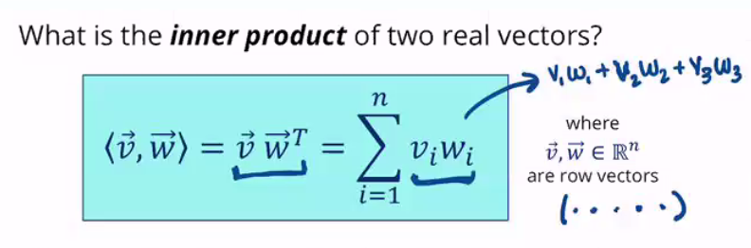

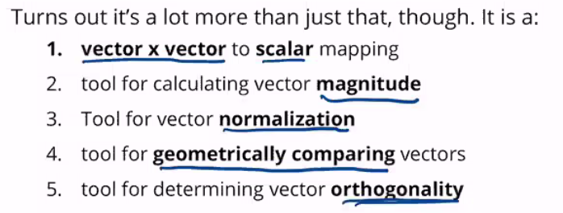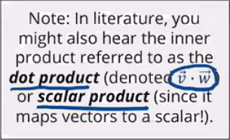

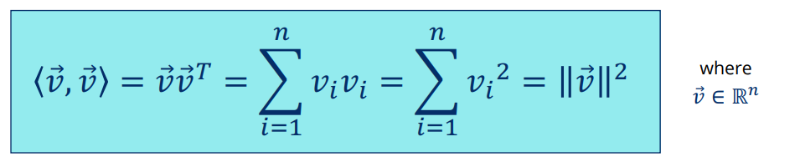

the inner product of a vector by itself gives magnitude2 . magnitude is also known as the norm

